**Appendix B: Online Appendix for “Estimating Parents’ Valuations of Class Size Reductions Using Attrition in the Tennessee STAR Experiment”**

This appendix describes ancillary results on attrition in the Tennessee STAR class size experiment; it is provided for the referees and not intended for publication. The six sections provide (i) evidence on the rates of attrition over time in Project STAR, (ii) detailed evidence on the rates of grade repetition in Project STAR, (iii) the effects of initially assigned class type on remaining years in small or regular with aide classes (Equations 4 and 5 from the main text), (iv) alternate estimates of the value of a change in class type for that allow $α_{ca}^{s}$ and $α_{ca}^{a}$ to be non-zero, (v) estimates of the value of a change in class type for the first and second grade entry cohorts, (vi) the demographic characteristics of kindergarteners in Project STAR as compared with kindergarteners eligible for the voucher programs discussed in Appendix A.

**B.I. Attrition from Project STAR over Time by Entry Cohort**

Figure B1 shows the rates at which students continued in the program in the same grade, class type, and school by year, shown separately by initial class type and grade of entry. Panels A, B, and C show these fractions for students entering in kindergarten, first grade, and second grade. Within each panel, the dark solid line shows the rate for students initially assigned to small classes, the light solid line shows the rate for students initially assigned to regular classes, and the dashed line shows the rate for students initially assigned to regular with aide classes. As in Table 1 of the main text, students whose schools left the program are excluded from the sample. Unlike in Table 1, however, students with missing values for the control variables and the absences variables are not dropped.

The differences in attrition rates are particularly striking for students who entered the program in kindergarten, with 67.4% of those assigned to small classes remaining into the next year, as compared to only 32.8% and 31.4% in regular and regular with aide classes, as panel A of Figure 2 shows. Much of the decline from kindergarten to first grade among students in regular and regular with aide classes is attributable to the re-randomization of class type for these students. Nevertheless, some of this difference is also attributable to students changing schools. The re-randomization only occurred for the kindergarten entry cohort after the first year; however, students’ class types changed in less systematic ways in other years. Also from panel A, the rates of exit from the sample in second and third grade were higher for students from regular classes than for students from other class types. In the remaining years, the attrition rates for small and regular classes moved roughly in parallel, indicating that the exit rate as a fraction of those remaining was higher for regular classes than for small classes. We observe slightly lower exit rates in later years among those assigned to regular with aide classes.

For students entering in first grade in panel B, roughly half remained in the sample after the first year, with the highest percent of 59.5% remaining among those in regular with aide classes, the lowest percent of 49.9% remaining among those in regular classes, and students from small classes in between at 55.8% remaining. The gap between regular and other class types widened by third grade, with an additional 17.5% of the original cohort leaving from regular classes, but only 12.6% to 12.7% leaving from regular with aide and small classes. A similar pattern is observable among students entering in second grade in panel C, with only 52.4% of those from regular classes remaining into third grade, as compared with 57.9% and 57.5% remaining among those from small and regular with aide classes.

**B.II. Effects of Initially Assigned Class Type on Grade Repetition**

The two panels of Figure B2 show the extent to which grade repetition varied across entry year and initial class type. Panel A shows the fraction of students whose teachers recommended grade repetition in at least one year while in Project STAR. As kindergarten was not mandatory in Tennessee Public Schools at the time, the data only include recommendations for grade repetition for first, second, and third grades. Panel B shows the fraction of students who were enrolled in public schools and had not completed grade eight by 1995, when most students from the cohort were in ninth grade. This fraction is measured as the proportion who took the TCAP achievement test, which is only required through eighth grade, in 1995, 1996, or 1997. Each panel shows three sets of bars, one for each of the entry cohorts. Within each set, the dark, light, and medium bars show grade repetition rates for students initially assigned to small, regular, and regular with aide classes.

Among students entering Project STAR in kindergarten, as panel A of Figure B2 shows, grade repetition was recommended for 11.4% to 11.5% of students assigned to regular or regular with aide classes, but for only 10.4% of children assigned to small classes. The lower rate of repetition for students in small classes could result from more generous promotion policies among teachers of small classes or from a causal effect of small classes on academic performance. As panel B shows, the fraction of the students who were below grade level and still in the public school system by 1995 is also slightly lower for students assigned to small classes in kindergarten than for students assigned to regular or regular with aide classes. The differences in panel B are not as large as in panel A, however, partly because the students in small classes left the public school system at lower rates than did students from other classes.

Among students entering the program in first or second grade, being recommended for repetition is most common for students assigned to regular classes and is slightly more common for those assigned to small classes than for those assigned to regular with aide classes. As panel A shows, for those entering in first grade, grade repetition was recommended for 18.7% of students in regular classes, 15.1% of those in small classes, and 14.4% of those in regular with aide classes. For those entering in second grade, repetition was recommended for 9.3% of those in regular classes, 7.9% of those in small classes, and 6.2% of those in regular with aide classes. As with the kindergarten entry cohort, these differences across class types could reflect differences across class types in policies toward retention or in the effectiveness at transmitting skills. Relative to students in small and regular with aide classes from these cohorts, students entering in both first and second grades and initially assigned to regular classes also exhibit higher rates of being in the public school system below grade level by 1995. As with those entering in kindergarten, however, the differences across class types are smaller than in panel A, due in part to the high rates of departure from the public school system among repeaters.

**B.III. Effects of Initial Class Type on Years in Small and Aide Classes**

Table B1 presents regressions estimating the effects of initially assigned class type on the number of later years spent in a small or regular with aide class. In each regression, the dependent variable measures the number of years spent in a certain class type after the first year. The regressors of interest and the control variables are the same as in Table 2 of the main text, but the samples are restricted to students who remained in Project STAR through third grade, as in panel B of Table 3 in the main text. Columns (1) to (4) show results for students who entered Project STAR in kindergarten, columns (5) to (8) show results for those entering in first grade, and columns (9) to (12) show results for those entering in second grade. In columns (1), (2), (5), (6), (9), and (10), the dependent variable is years spent in a Project STAR small class; in columns (3), (4), (7), (8), (11), and (12), the dependent variable is years spent in a regular class with an aide. The maximum numbers of remaining years spent in a given class type are three, two, and one for the kindergarten, first grade, and second grade entry cohorts, respectively.

For students entering Project STAR in kindergarten and remaining through third grade, the results from columns (1) to (4) indicate that, relative to assignment in a regular class, assignment to a small class in kindergarten is associated with 2.41 to 2.44 more years of a small class and 1.24 to 1.28 fewer years of a regular with aide class over grades one to three. Also for the kindergarten entry cohort, we find little difference between students initially assigned to regular with aide versus regular classes in the remaining years spent in small or regular with aide classes, due to the re-randomization of class type for these students. Among students who entered Project STAR in first grade and remained through third grade, we find that, relative to assignment in a regular class, being assigned to a small class in grade one is associated with 1.62 to 1.64 more years in a small class and 0.14 to 0.20 fewer years in a regular with aide class for grades two and three. We find the reverse pattern for students from the first grade cohort who were initially assigned to regular with aide classes. Relative to those assigned to regular classes, students assigned to regular with aide classes in first grade spent 1.54 to 1.55 more years in regular with aide classes and 0.20 fewer years in small classes over grades two and three. For students who entered the program in grade two and remained in grade three, we find that, relative to a regular class, being assigned to a small class in grade two is associated with a 0.86 to 0.88 greater probability of spending third grade in a small class and a 0.09 to 0.10 lower probability of spending third grade in a regular with aide class. Also relative to those assigned to regular classes among those entering in grade two and remaining in grade three, we find that students assigned to regular with aide classes had a 0.83 to 0.84 greater probability of spending third grade in a regular with aide class and a 0.07 to 0.10 lower probability of spending third grade in a small class. Of the 24 differences estimated in Table B1, all are statistically significant except for the four coefficients on regular with aide for the kindergarten cohort (the group affected by the re-randomization).

**B.IV. Estimated Value of Class Size When $α_{ca}^{s}$ and $α_{ca}^{a}$ are Non-Zero**

If the constants $α_{ca}^{s}$ and $α_{ca}^{a}$ from Equation (5) are not equal to zero, then it is possible to separately identify families’ valuations of a year in a small or regular with aide classes relative to a regular class. In practice, because $α_{ca}^{s}$ and $α_{ca}^{a}$ are very close to zero, these estimates are highly imprecise; for completeness, however, these estimates are provided here in web appendix. For a given cohort $c$, let $ρ_{cs}^{L}$ denote the degree to which an additional expected future year in a small class (relative to a regular class) would reduce a student’s likelihood of leaving the school. Similarly, let $ρ_{ca}^{L}$ denote the effect of an additional expected future year in a regular with aide class (also relative to a regular class) on the likelihood of changing schools. Hence, we assume that $β_{cts}^{L}$ and $β_{cta}^{L}$, the effects from Equation (1) of small and regular with aide class assignments on leaving one’s initial school, can be expressed as weighted sums of the per year responses $ρ_{cs}$ and $ρ_{ca}$, where the weights are given by the following equations:

(B1) $β_{cts}^{L}=α_{cs}^{s}*ρ_{cs}^{L}+α_{cs}^{a}*ρ_{ca}^{L}$, and

(B2) $β_{cta}^{L}=α_{ca}^{s}*ρ_{cs}^{L}+α_{ca}^{a}*ρ_{ca}^{L}$.

Relative to assignment in a regular class, an initial assignment of a small class has associated with it $α_{cs}^{s}$ additional expected future years of small class and $α_{cs}^{a}$ additional expected future years of a regular class with aide. The effect $β_{cts}^{L}$ of initial assignment of small class on changing schools is assumed to equal $α_{cs}^{s}$ times the attrition response $ρ_{cs}^{L}$ per future year of small class plus $α_{cs}^{a}$ times the attrition response $ρ_{ca}^{L}$ per future year of regular with aide class. Rearranging terms, the responses of interest $ρ_{cs}^{L}$ and $ρ_{ca}^{L}$ can be expressed in terms of estimable parameters as:

(B3) $ρ_{cs}^{L}={\left[β_{cts}^{L}-\left(\frac{α_{cs}^{a}}{α_{ca}^{a}}\right)β_{cta}^{L}\right]}/{\left[α_{cs}^{s}-\left(\frac{α_{cs}^{a}}{α_{ca}^{a}}\right)*α_{ca}^{s}\right]}$, and

(B4) $ρ_{ca}^{L}={\left[β_{cta}^{L}-\left(\frac{α_{ca}^{s}}{α_{cs}^{s}}\right)β_{cts}^{L}\right]}/{\left[α_{ca}^{a}-\left(\frac{α_{ca}^{s}}{α_{cs}^{s}}\right)α_{cs}^{a}\right]}$.

Estimates using this approach appear in Table B2. The structure of the table is the same as in Table 4 of the main text, except that estimates are presented in two panels. Panel A shows estimates of the attrition response to a yearlong switch from a regular to a small class, and panel B shows estimates of the attrition response to a yearlong switch from a regular to a regular with aide class. As the table shows, the estimates are extremely imprecise, with the standard errors often many times larger in magnitude than the coefficient estimates. The estimates are very sensitive to the inclusion of controls, and they vary widely across the four samples, exhibiting positive as often as negative signs and producing valuations ranging from -$1.2 million to +$0.6 million.

**B.V.The Value of Class Type for the First and Second Grade Entry Cohorts**

In order to accurately represent the tradeoffs faced by students who entered Project STAR in grades one and two, for whom class type was sensitive to parental pressure, it is necessary to consider changes in class type as a major form of sample attrition. For a given cohort $c$, let $ρ_{cs}^{LC}$ and $ρ_{ca}^{LC}$ denote the degree to which an expected future year in a small class and a year in a regular with aide class (relative to a regular class) would reduce a student’s likelihood of leaving the school or changing class type within schools. For this model in which class type is endogenous, the baseline course of action against which alternatives are compared is to remain in one’s assigned school and class type for the remainder of the experiment. For students in the second grade entry cohort, only one year of class remained, and $ρ_{cs}^{LC}$ and $ρ_{ca}^{LC}$ can be expressed as $β_{cts}^{L}+β_{cts}^{C}$ and $β_{cta}^{L}+β_{cta}^{C}$, the observed attrition responses to initial assignments of small and regular with aide classes. We assume that parents or children who entered in first grade and remained in their assigned classes for second grade expected to keep those class assignments through third grade. Hence, for students who entered Project STAR in first grade, we estimate $ρ_{cs}^{LC}$ and $ρ_{ca}^{LC}$ as $\frac{β_{cts}^{L}+β_{cts}^{C}}{2}$ and $\frac{β_{cta}^{L}+β_{cta}^{C}}{2}$.

Tables B3 and B4 present estimates of the attrition response per yearlong change in class type for the first and second grade entry cohorts, respectively. The tables are structured in the same way as in Table B2. However, rather than present ratios of coefficients as in Table B2, the attrition responses shown are $\frac{β_{cts}^{L}+β_{cts}^{C}}{2}$ and $\frac{β_{cta}^{L}+β_{cta}^{C}}{2}$ for the first grade entry cohort and $β_{cts}^{L}+β_{cts}^{C}$ and $β_{cta}^{L}+β_{cta}^{C}$ for the second grade entry cohort. The sums of coefficients are estimated in all four columns from regressions in which the maximum of ${Left School}_{ict}$ and ${ChangedClass}_{ict}$ is the dependent variable.

For the first grade entry cohort in Table B3, our estimated value of a small class for inner city families ranges from $7,909 to $25,083, a similar range of values as we find for the kindergarten cohort. We find considerably smaller values, ranging from $96 to $3,775, for a teacher’s aide. For suburban students, our estimated valuation of a small class ranges from $2,105 to $15,456 – also similar to what we find for the kindergarten cohort, and we find a similar value of a teacher’s aide, with estimates ranging from $1,105 to $19,865.

For students from the first grade entry cohort in small urban areas, we obtain negative valuations of small classes and strikingly large valuations for teacher’s aides (ranging from $120,121 to $383,163). The positive effect of small class probably appears in large part due to the large amount of imprecision in the estimates. Some of the very negative effect of teacher’s aide may reflect a greater ability of students to change class types from regular classes than from regular with aide classes (if, for instance, administrators are more sensitive to pressure from parents of students in regular classes). However, the evidence is also consistent with the view that parents in small urban areas had a strong preference for teacher’s aides due to the additional assistance that they provided students. For rural areas, we estimate large valuations of changes in class type as well, with our estimated value of a small class ranging from $10,984 to $53,151 and our estimated value of an aide ranging from $18,946 to $56,382. These very large estimated valuations for changes in class type in small urban and for rural areas are largely attributable to incorrect estimates of the slope of the demand curve. As mentioned in the main text, changing class types – a key form of attrition, particularly in small urban and in rural areas – is probably a more price elastic behavior than is changing schools. Hence, it is likely that the estimates suffer from an extenuation bias and that using the correct slope of the demand curve would generate smaller estimated valuations.

For the second grade entry cohort in Table B4, we also obtain very large estimated valuations of changes in class type due in part to the use of price elasticities that are too small. For inner city students, we obtain estimated valuations of a yearlong change to small class that range from $32,592 to $117,325, and our estimated valuations for a yearlong change to a class with an aide range from $31,459 to $96,752. For suburban students, our estimated valuations are similar to what we find for the first grade entry cohort. We find fairly strong positive effects of small and regular with aide classes on attrition for the smaller urban areas – the reason for this positive effect is unclear. Finally, we find highly imprecise estimated valuations for rural families, ranging from -$20,381 to +$108,352 for a yearlong change to a small class and $38,916 to $142,291 for a yearlong change to a regular with aide class.

**B.VI. Comparison Between STAR and Voucher Samples**

To examine the comparability of the Project STAR participants with the students in the voucher programs discussed in Appendix A, Table B5 shows sample means for a handful of characteristics for the STAR data and the populations meeting the eligibility criteria for four of the voucher studies. Panel A shows means when the sample is restricted to kindergarteners enrolled in public schools, and panel B shows means for kindergarteners in public or private schools. Columns (1) to (4) shows estimates for the different levels of urbanization from the Project STAR data, and columns (5) to (8) show estimates for New York kindergarteners at or below 185% of the poverty line, Dayton, OH kindergarteners at or below 200% poverty, Washington D.C. kindergarteners at or below 270% poverty, and Milwaukee kindergarteners at or below 175% poverty.

In general the inner city students in Project STAR schools are fairly similar to the students in the voucher samples, and the Project STAR samples from suburban, small urban, and rural areas tend to include fewer black students and poor students than we observe in the voucher samples. As the results from Table B5 show, the fractions of students who were black and who were eligible for free lunch is higher, at 0.976 and 0.904, for students from inner city schools in Project STAR than for voucher eligible students in the five cities studied, where the fraction black ranged from 0.362 to 0.812 and the fraction eligible for free lunch ranged from 0.617 to 0.800. Students in Project STAR schools at other levels of urbanization all showed lower fractions black and lower fractions eligible for free lunch than in the voucher samples. At all four levels of urbanization, kindergarteners in Project STAR tend to be older (with ages ranging from 5.441 to 5.537) than those in the voucher cities, where the ages ranged from 5.092 to 5.137 plus one particularly high average age of 5.582 for the Dayton sample.

|  |  |  |  |  |  |  |  |  |  |  |  |  |
| --- | --- | --- | --- | --- | --- | --- | --- | --- | --- | --- | --- | --- |
| Table B1: OLS Estimates of Effects of Initial Class Type on Remaining Years in Small Class and  Remaining Years in Regular with Aide Classes among Students Remaining in Project STAR | | | | | | | | | | | | |
|  | (1) | (2) | (3) | (4) | (5) | (6) | (7) | (8) | (9) | (10) | (11) | (12) |
| Initial Class Type | Entered Project STAR in Kindergarten | | | | Entered Project STAR in First Grade | | | | Entered Project STAR in Second Grade | | | |
| Years in Small Class | | Years in Regular Class with Aide | | Years in Small Class | | Years in Regular Class with Aide | | Years in Small Class | | Years in Regular Class with Aide | |
| Small | 2.408 | 2.439 | -1.238 | -1.282 | 1.641 | 1.616 | -0.204 | -0.143 | 0.877 | 0.863 | -0.088 | -0.100 |
|  | (0.057)** | (0.041)** | (0.057)** | (0.045)** | (0.060)** | (0.064)** | (0.052)** | (0.057)** | (0.026)** | (0.026)** | (0.033)** | (0.034)** |
|  |  |  |  |  |  |  |  |  |  |  |  |  |
| Regular | -0.027 | -0.032 | 0.076 | 0.052 | -0.204 | -0.196 | 1.546 | 1.537 | -0.073 | -0.096 | 0.843 | 0.827 |
| w/ Aide | (0.057) | (0.037) | (0.073) | (0.051) | (0.052)** | (0.044)** | (0.065)** | (0.064)** | (0.024)** | (0.026)** | (0.039)** | (0.041)** |
|  |  |  |  |  |  |  |  |  |  |  |  |  |
| Controls? |  | Yes |  | Yes |  | Yes |  | Yes |  | Yes |  | Yes |
| School Fixed Effects? | | Yes |  | Yes |  | Yes |  | Yes |  | Yes |  | Yes |
|  |  |  |  |  |  |  |  |  |  |  |  |  |
| R2 | 0.795 | 0.818 | 0.374 | 0.410 | 0.813 | 0.834 | 0.847 | 0.865 | 0.935 | 0.944 | 0.932 | 0.939 |
| N (Students) | 2,977 | | | | 1,030 | | | | 935 | | | |
| Clusters | 306 | | | | 279 | | | | 280 | | | |

Notes to Table B1: Each column shows estimates from an OLS regression in which the outcome variable is years spent in a small class after one’s first year in Project STAR (in columns 1, 2, 5, 6, 9, and 10) or years spent in a regular class with aide after one’s first year in Project STAR (in columns 3, 4, 7, 8, 11, and 12). In each case, the sample includes students who remained in Project STAR from the year of entry into third grade. Controls are the same as in Table 2 of the main text, and each regression adjusts for clustering at the level of initially assigned classroom.

|  |  |  |  |  |  |  |  |  |  |  |  |  |  |
| --- | --- | --- | --- | --- | --- | --- | --- | --- | --- | --- | --- | --- | --- |
| Table B2: Estimated Economic Value of Class Size Reductions and Teachers' Aides when Aide Affects Attrition and Remaining Years in Different Class Types, Kindergarten Entry Cohort | | | | | | | | | | | | | |
|  | (1) | (2) | | (3) | | (4) | | (5) | (6) | (7) | | (8) | |
|  | Panel A: Small Class | | | | | | | | | | |  | |
|  | Inner City | | Suburban | | | | Urban, not Inner City | | | | Rural | | |
|  |  |  |  | |  | |  | |  | |  | |  |
| Attrition effect per year of change in class type | -0.399 | -1.099 | 0.044 | | 0.036 | | 0.448 | | 0.169 | | 0.012 | | -0.015 |
| (1.038) | (6.550) | (0.178) | | (0.087) | | (1.107) | | (0.259) | | (0.075) | | (0.056) |
| Value per year assuming. . . |  |  |  | |  | |  | |  | |  | |  |
| 0.006 response per $1,000 voucher | $66,421 | $183,182 | -$7,254 | | -$5,994 | |  | |  | |  | |  |
| 0.002 response per $1,000 voucher | $199,264 | $549,547 | -$21,762 | | -$17,983 | |  | |  | |  | |  |
| 0.001 response per $1,000 voucher |  |  |  | |  | | -$448,042 | | -$168,651 | | -$12,262 | | $14,550 |
| 0.0004 response per $1,000 voucher |  |  |  | |  | | -$1,120,104 | | -$421,627 | | -$30,654 | | $36,376 |
|  |  |  |  | |  | |  | |  | |  | |  |
|  | Panel B: Regular Class with Aide | | | | | | | | | | | | |
| Attrition effect per year of change in class type | -0.245 | -1.134 | | -0.562 | | -0.350 | | 0.288 | 0.374 | | 0.026 | | -0.010 |
| (0.456) | (7.721) | | (4.925) | | (1.137) | | (0.536) | (0.689) | | (0.121) | | (0.082) |
| Value per year assuming. . . |  |  | |  | |  | |  |  | |  | |  |
| 0.006 response per $1,000 voucher | $40,773 | $188,973 | | $93,713 | | $58,272 | |  |  | |  | |  |
| 0.002 response per $1,000 voucher | $122,320 | $566,920 | | $281,140 | | $174,815 | |  |  | |  | |  |
| 0.001 response per $1,000 voucher |  |  | |  | |  | | -$288,023 | -$373,788 | | -$25,948 | | $9,820 |
| 0.0004 response per $1,000 voucher |  |  | |  | |  | | -$720,058 | -$934,471 | | -$64,870 | | $24,549 |
|  |  |  | |  | |  | |  |  | |  | |  |
| Controls? |  | Yes | |  | | Yes | |  | Yes | |  | | Yes |
| School Fixed Effects? | | Yes | |  | | Yes | |  | Yes | |  | | Yes |

Notes to Table B2: This table presents estimates of the attrition response per yearlong change in class type for students from the kindergarten entry cohort. This attrition effect is measured relative to a year of regular-sized class using the parameter estimates from Table 2 according to the formulas described in Equations (B3) and (B4) separately by level of urbanization. The standard errors are calculated by simultaneously estimating attrition regressions as in Table 2 from the main text and the years in small class and years in regular with aide class regressions as in Table B1 (but both estimated separately by level of urbanization) using seemingly unrelated regression (suest in Stata) and using the delta method (nlcom in Stata). The parameters are converted to valuations per yearlong change in the same way as in Table 4 of the main text.

|  |  |  |  |  |  |  |  |  |
| --- | --- | --- | --- | --- | --- | --- | --- | --- |
| Table B3: Estimated Economic Value of Class Size Reductions and Teachers' Aides, First Grade Entry Cohort | | | | | | | | |
|  | (1) | (2) | (3) | (4) | (5) | (6) | (7) | (8) |
|  | Panel A: Small Class | | | | | | |  |
|  | Inner City | | Suburban | | Urban, not Inner City | | Rural | |
|  |  |  |  |  |  |  |  |  |
| Attrition effect per year of change in class type | -0.047 | -0.050 | -0.031 | -0.013 | 0.020 | 0.029 | -0.011 | -0.021 |
| (0.031) | (0.029)* | (0.039) | (0.035) | (0.076) | (0.049) | (0.026) | (0.025) |
| Value per year assuming. . . |  |  |  |  |  |  |  |  |
| 0.006 response per $1,000 voucher | $7,909 | $8,361 | $5,152 | $2,105 |  |  |  |  |
| 0.002 response per $1,000 voucher | $23,728 | $25,083 | $15,456 | $6,315 |  |  |  |  |
| 0.001 response per $1,000 voucher |  |  |  |  | -$20,068 | -$29,174 | $10,984 | $21,261 |
| 0.0004 response per $1,000 voucher |  |  |  |  | -$50,170 | -$72,935 | $27,460 | $53,151 |
|  |  |  |  |  |  |  |  |  |
|  | Panel B: Regular Class with Aide | | | | | | | |
| Attrition effect per year of change in class type | -0.008 | -0.001 | -0.040 | -0.007 | -0.120 | -0.155 | -0.023 | -0.019 |
| (0.032) | (0.025) | (0.036) | (0.020) | (0.064)* | (0.039)** | (0.022) | (0.017) |
| Value per year assuming. . . |  |  |  |  |  |  |  |  |
| 0.006 response per $1,000 voucher | $1,258 | $96 | $6,622 | $1,105 |  |  |  |  |
| 0.002 response per $1,000 voucher | $3,775 | $288 | $19,865 | $3,314 |  |  |  |  |
| 0.001 response per $1,000 voucher |  |  |  |  | $120,121 | $155,265 | $22,553 | $18,946 |
| 0.0004 response per $1,000 voucher |  |  |  |  | $300,303 | $388,163 | $56,382 | $47,365 |
|  |  |  |  |  |  |  |  |  |
| Controls? |  | Yes |  | Yes |  | Yes |  | Yes |
| School Fixed Effects? | | Yes |  | Yes |  | Yes |  | Yes |

Notes to Table B3: This table presents estimates of the attrition response per yearlong change in class type for students from the first grade entry cohort. This attrition effect is measured relative to a year of regular-sized class based upon regressions of “changed school or class type” on indicators for small and regular with aide class. The coefficients are then divided by two to obtain an attrition response per yearlong change (due to the two remaining years of second and third grade in Project STAR) as described in the text of this appendix. The parameters are converted to valuations per yearlong change in the same way as in Table 4 of the main text

|  |  |  |  |  |  |  |  |  |
| --- | --- | --- | --- | --- | --- | --- | --- | --- |
| Table B4: Estimated Economic Value of Class Size Reductions and Teachers' Aides, Second Grade Entry Cohort | | | | | | | | |
|  | (1) | (2) | (3) | (4) | (5) | (6) | (7) | (8) |
|  | Panel A: Small Class | | | | | | |  |
|  | Inner City | | Suburban | | Urban, not Inner City | | Rural | |
|  |  |  |  |  |  |  |  |  |
| Attrition effect per year of change in class type | -0.196 | -0.235 | -0.032 | -0.017 | 0.124 | 0.241 | 0.008 | -0.043 |
| (0.091)** | (0.089)** | (0.073) | (0.059) | (0.092) | (0.108)** | (0.061) | (0.059) |
| Value per year assuming. . . |  |  |  |  |  |  |  |  |
| 0.006 response per $1,000 voucher | $32,592 | $39,108 | $5,376 | $2,874 |  |  |  |  |
| 0.002 response per $1,000 voucher | $97,776 | $117,325 | $16,129 | $8,622 |  |  |  |  |
| 0.001 response per $1,000 voucher |  |  |  |  | -$124,138 | -$240,758 | -$8,152 | $43,341 |
| 0.0004 response per $1,000 voucher |  |  |  |  | -$310,345 | -$601,895 | -$20,381 | $108,352 |
|  |  |  |  |  |  |  |  |  |
|  | Panel B: Regular Class with Aide | | | | | | | |
| Attrition effect per year of change in class type | -0.194 | -0.189 | -0.029 | -0.043 | 0.018 | 0.300 | -0.039 | -0.057 |
| (0.093) | (0.068) | (0.069) | (0.054) | (0.070) | (0.099)** | (0.051) | (0.049) |
| Value per year assuming. . . |  |  |  |  |  |  |  |  |
| 0.006 response per $1,000 voucher | $32,251 | $31,459 | $4,876 | $7,109 |  |  |  |  |
| 0.002 response per $1,000 voucher | $96,752 | $94,377 | $14,629 | $21,326 |  |  |  |  |
| 0.001 response per $1,000 voucher |  |  |  |  | -$18,256 | -$300,288 | $38,916 | $56,917 |
| 0.0004 response per $1,000 voucher |  |  |  |  | -$45,639 | -$750,721 | $97,289 | $142,291 |
|  |  |  |  |  |  |  |  |  |
| Controls? |  | Yes |  | Yes |  | Yes |  | Yes |
| School Fixed Effects? | | Yes |  | Yes |  | Yes |  | Yes |

Notes to Table B4: This table presents estimates of the attrition response per yearlong change in class type for students from the second grade entry cohort. The estimates are constructed in the same way as in Table B3; however, the coefficients are not divided by two, because only one year remained in Project STAR after second grade.

|  |  |  |  |  |  |  |  |  |
| --- | --- | --- | --- | --- | --- | --- | --- | --- |
| Table B5: Descriptive Statistics, Tennessee STAR and Program Eligible Kindergarteners in Voucher Cities | | | | | | | | |
|  | (1) | (2) | (3) | (4) | (5) | (6) | (7) | (8) |
|  | Tennessee STAR, 1985 | | | | Eligible Kindergarteners in Voucher Cities (2000 Census) | | | |
| Variable | Inner City | Suburban | Urban, Not Inner City | Rural | New York, NY | Dayton, OH | Washington, D.C. | Milwaukee, WI |
| Panel A: Sample Restricted to Students Attending Public Schools | | | | | | | | |
| Black | 0.976 | 0.325 | 0.103 | 0.060 | 0.363 | 0.362 | 0.812 | 0.671 |
|  | (0.004) | (0.013) | (0.015) | (0.004) | (0.011) | (0.043) | (0.025) | (0.033) |
|  |  |  |  |  |  |  |  |  |
| Age on | 5.441 | 5.488 | 5.537 | 5.531 | 5.137 | 5.582 | 5.092 | 5.130 |
| April 1 | (0.014) | (0.014) | (0.026) | (0.010) | (0.016) | (0.059) | (0.044) | (0.058) |
|  |  |  |  |  |  |  |  |  |
| Urban | 1.000 | 0.000 | 1.000 | 0.000 | 1.000 | 0.455 | 1.000 | 1.000 |
|  | (0.000) | (0.000) | (0.000) | (0.000) | (0.000) | (0.045) | (0.000) | (0.000) |
|  |  |  |  |  |  |  |  |  |
| Eligible for | 0.904 | 0.276 | 0.424 | 0.404 | 0.772 | 0.667 | 0.617 | 0.800 |
| Free Lunch | (0.008) | (0.012) | (0.024) | (0.009) | (0.009) | (0.042) | (0.031) | (0.028) |
|  |  |  |  |  |  |  |  |  |
| Observations | 1,318 | 1,306 | 436 | 2,814 | 1,977 | 125 | 253 | 204 |
|  |  |  |  |  |  |  |  |  |
| Panel B: Sample Includes Students in Public and Private Schools | | | | | | | | |
|  |  |  |  |  |  |  |  |  |
| Attending Private |  |  |  |  | 0.160 | 0.100 | 0.041 | 0.116 |
| School |  |  |  |  | (0.008) | (0.025) | (0.012) | (0.021) |
|  |  |  |  |  |  |  |  |  |
| Observations |  |  |  |  | 2,354 | 140 | 278 | 228 |

Notes to Table B5: Sample means presented with standard errors of the sample means in parentheses. Tennessee STAR sample is the same as in panel A of Table 1 of the main text. Voucher city samples include kindergarteners in the April 2000 Census who satisfied the residency and income eligibility requirements for the voucher programs as described in Table A1 of the main text. The 2000 Census is used rather than the 1990 Census for Milwaukee because the 1990 Census does not include data on “grade currently attending.” “Black” is used rather than “white/Asian” because, given the multiple racial categories in the 2000 Census, “white” is difficult to identify in a way that corresponds with the Project STAR data. Means are not shown for San Antonio and Pensacola because those eligible populations are defined based upon school district and school attendance areas not measured in the Census.

Figure B1: Fraction Still in Assigned Grade, Class Type, and School by Year of Entry into Project STAR and Grade

Panel A: Entered Project STAR in Grade K Panel B: Entered Project STAR in Grade 1

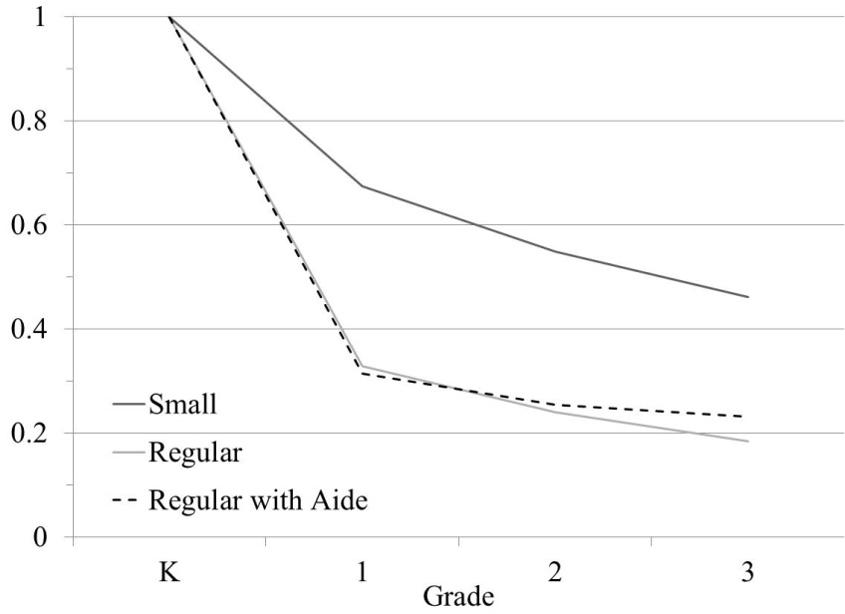 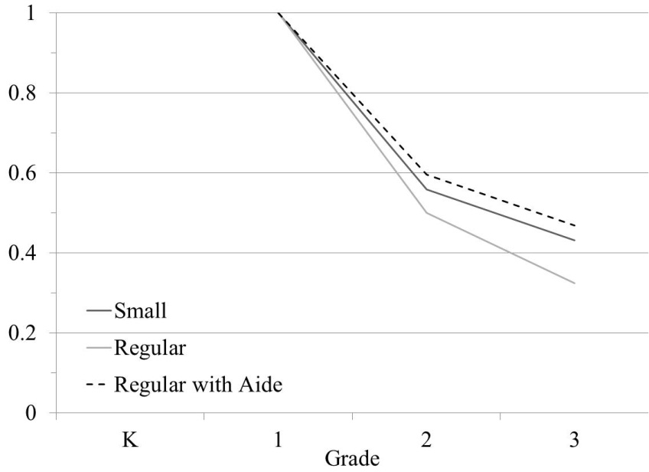

Panel C: Entered Project STAR in Grade 2

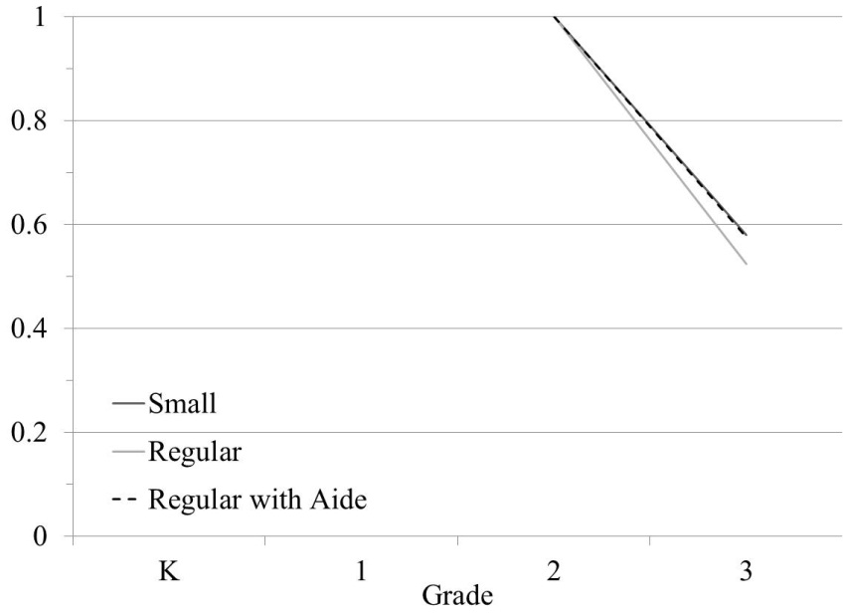

Notes to Figure B1: Data source is Tennessee STAR program data. Students from schools that left Project STAR are excluded from the sample. For the kindergarten entry cohort in panel A, much of the difference in attrition rates between small and other class types is attributable to a re-randomization of class types after the first year for students in regular and regular with aide classes. Additional details in the text.

Figure B2: Grade Repetition by Year of Entry and Initially Assigned Class Type

Panel A: Teacher Recommended Grade Repetition in Some Project STAR Year

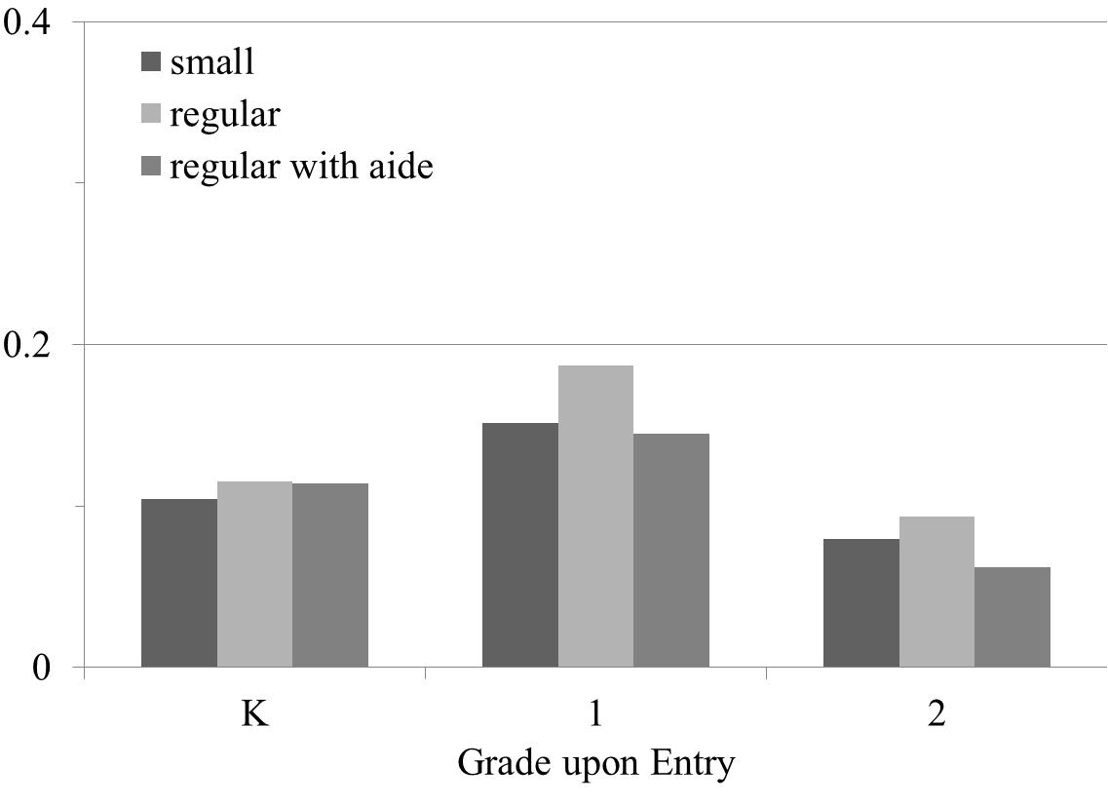

Panel B: Took TCAP in 1995 or Later

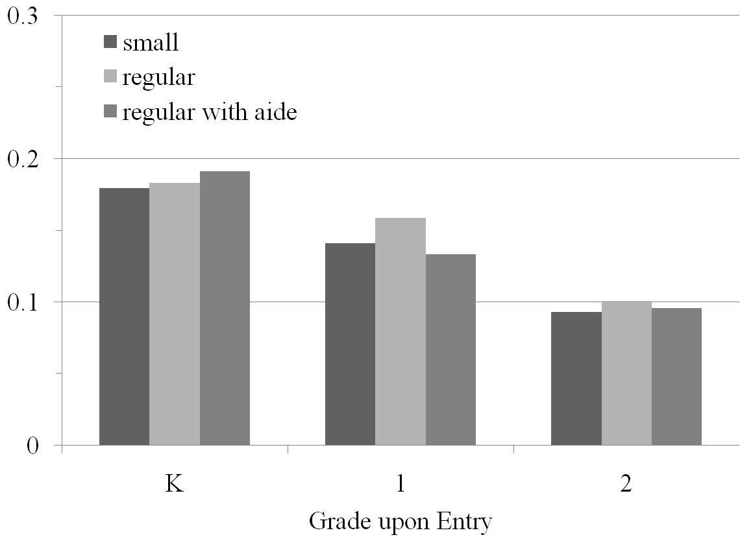

Notes to Figure B2: “Teacher recommended grade repetition” taken from Project STAR data; sample includes all students whose schools did not leave the program. Because the TCAP was only taken through eighth grade, a student in the STAR cohort who was making regular progress would not have taken the TCAP in 1995 or later. Hence, this outcome indicates that the student remained in the public school system through 1995 and repeated at least one grade.